Day 10 WebServers, Servlets, JSP

Day 9 Revisit

SOLID Principles

Design Patterns

SonarQube – Demo

NFR

DRY PRINCIPLES

* S 🡪 Single Responsibility (SRP)
* O 🡪 Open /Closed (OCP)
* L 🡪 Liskov Substitution (LSP)
* I 🡪 Interface Segregation (ISP)
* D 🡪 Dependency Inversion (DIP)

Writing Efficient, Maintainable, Clean & Secure

DRY – Don’t Repeat Yourself (Reuse the existing resources as much as possible)

Design Patterns – Proven/efficient way of solving problems

* Creational (Singleton, Factory, Builder, Prototype, Object Pool, DI)
* Structural ( Decorator, Front Controller, Bridge, Proxy, Module)
* Behavioural (Chain of Responsibility, State, Iterator, Specification)
* Concurrency (Join, Lock, Thread Pool, Scheduler)

NFR – Non-Functional Requirements (Performance, Scalability, Security, ….)

JMeter , Selenium

SonarQube ( Min JDK should be 11) – Static Code Analysis (Code Smell)

* Security/Vulnerabilities
* Helps to write clean code
* Scans for any other threats and generate reports
* It also consider the overall test coverage

Run with Coverage (In IDE)

Sonarlint – Sonar plugin for IDE

Design Principle

YAGNI - YAGNI principle ("You Aren't Gonna Need It") is a practice in software development which states that features should only be added when required.

Day 10.

Types of Servers (Client & Server Concepts)

* Web Server ( Helps to send and receive data using web protocols) Tomcat (Servlets,JSP), IIS,
* Application Server ( WebLogic, WebSphere, JBoss … )
* Database Server ( Mongo/MySQL)

1. Request Object (Client sends request to server)
2. Response Object ( For every valid request, server creates a response and send it back to client)

* Jenkins Server (Automation Server)
* MongoDB/MySQL
* SonarQube

Types of Java Application

* Java Stand Alone Applications (CLI based/GUI based with a Starter class [class with main method]) {core Java Applications} – JAR (Java Archive)
* Web/Enterprise Application {Adv Java Applications/ JEE Application} – WAR/EAR (Web/Enterprise Archive)

Entry point

* For Stand alone application – Starter class (Class with main method)
* For Web/Enterprise Application – web.xml (if it is present) [web.xml is optional]

Web.xml 🡪 Deployment Descriptor

Flavours of Java

* J2SE 🡪 Java 2 Standard Edition
* J2EE 🡪 Java 2 Enterprise Edition
* J2ME 🡪 Java 2 Micro Edition

Creating first Web based application in Eclipse EE IDE

Open Eclipse EE IDE

1. File🡪 New🡪 Other
2. Select “Dynamic Web App” under web folder
3. Provide the name of the application and configure target runtime.

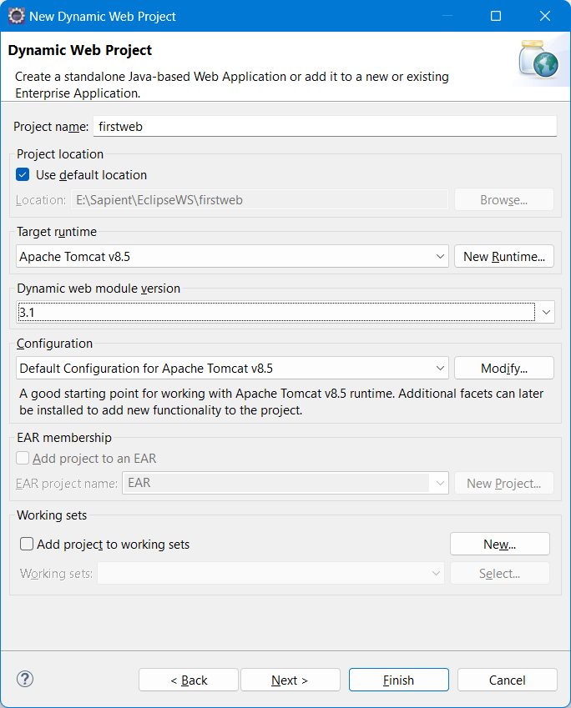

1. Configure tomcat port number and run the app on server
2. Create first servlet

What is Servlet – Servlet is a adv Java Class which extends either Http/Generic Servlet

Types of Servlet

1. Generic Servlet
2. Http Servlet

Protocol – Set of Rules

Servlet – HTML code is embedded inside java code

JSP – Java Server Pages – (Java code embedded inside html code)

Every browser will have 3 engines

1. HTML Rendering Engine
2. Styling Engine
3. JS Engine

Static Web – Content won’t change wrt time &/ user

Dynamic Web – Content will change wrt time &/ user

<% %> = JSP Scriptlet (Multi line tag)

<%@ %> = JSP Directive (Single Line tag) [page,include,taglib]

<jsp:dataSource> </jsp:dataSource> = JSP Action Tags (Single line)

<%= %> - JSP Expression Tag (Single line Tag) (out.print)

<%! %> -JSP Declaration Tag

<!-- -- > == HTML Comments

<%-- --> = JSP Comments (Multi line)

9 Implicit Object in JSP

Out

Respone

Request

Session

Config

Page

Exception

PageContext

Application

JSTL – JSP Standard Tag Library

${} = Expression Language Syntax